**DAILY ONLINE ACTIVITIES SUMMARY**

|  |  |  |  |  |  |  |  |  |
| --- | --- | --- | --- | --- | --- | --- | --- | --- |
| **Date:** | **25/06/2020** | | | | | **Name:** | **Anjali Manohar Prabhu** | |
| **Sem & Sec** | **4th Sem Section - ‘A’** | | | | | **USN:** | **4AL18CS007** | |
| **Online Test Summary** | | | | | | | | |
| **Subject** | | **N/A** | | | | | | |
| **Max. Marks** | | **N/A** | | **Score** | | | **N/A** | |
| **Certification Course Summary** | | | | | | | | |
| **Course** | **Webminar on C++** | | | | | | | |
| **Certificate Provider** | | | 1. **Great Learning Academy** | | **Duration** | | | **11.0hrs** |
| **Coding Challenges** | | | | | | | | |
| **Problem Statement:**   1. Write a C program to reverse the rows in a 2d array | | | | | | | | |
| **Status: Executed** | | | | | | | | |
| **Uploaded the report in Github** | | | | | **YES** | | | |
| **If yes Repository name** | | | | | [**https://github.com/vinisharen/lockdown-coding**](https://github.com/vinisharen/lockdown-coding) | | | |
| **Uploaded the report in slack** | | | | | **YES** | | | |

Online Test Details: N/A

Certification Course Details: Webinar details: Webinar on C++

Attended a session on C program(9:00am to 11:00am) which was organized by AIET Placement Department in Google meet and the session was conducted by Prof. Shruthi Shetty .The duration of the session was 2 hours. A quiz was conducted on the particular topic at the end of the session. And the marks that I scored was 20/30

**SNAPSHOT:**

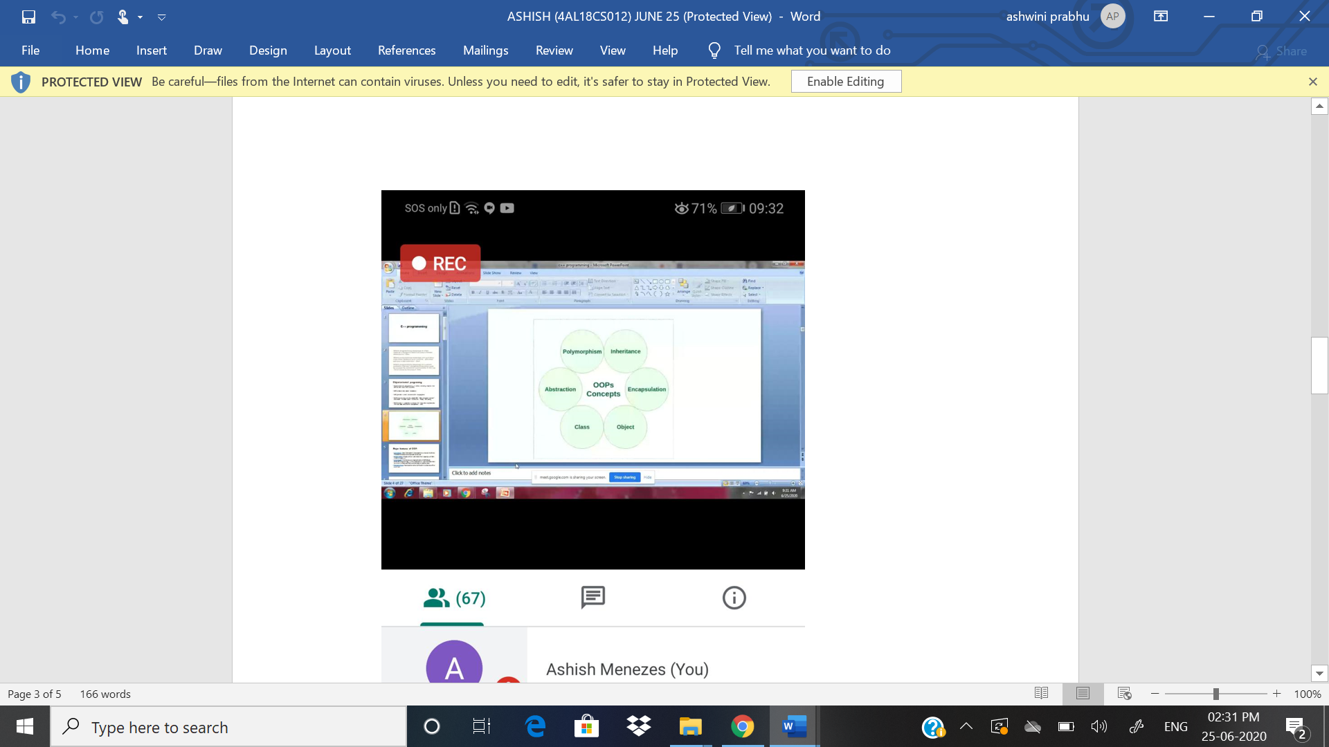

ONLINE CODING DETAILS:

PROBLEM 1: Write a C program to reverse a row in a 2d array

SNAPSHOT:

